
COMSATS UNIVERSITY ISLAMABAD, ATTOCK CAMPUS

Computer Science Department
BSSE-4
SOFTWARE DESIGN AND ARCHITECTURE

PROJECT TITLE: COURIER MANAGEMENT SYSTEM
SUBMITTED TO :
MAAM SUNDAS SHIREEN

SUBMITTED BY :
ZAINAB KHAN
FA22-BSE-032

DESCRIPTION :
A Courier Management System (CMS) is a comprehensive platform designed to facilitate and streamline the processes involved in managing courier and delivery services. It integrates various modules to handle different aspects of the courier business. The system aims to improve efficiency, accuracy, and customer satisfaction by automating tasks, providing real-time updates, and maintaining detailed records.
KEY FEATURES
1.Customer
Attributes:
Customer ID: Integer
name: String
email: String
phone Number: String
address: String
2. Order
Attributes:
Order ID: Integer
Customer ID: Integer
Order Number:INT
Booking Date: Date
3.Employee
Attributes:
Employee ID: Integer
name: String
email: String
hire Date: Date
salary: Double
4.Admin
Attributes:
Login: String
Admin ID: Integer
name: String
email: String
phone Number : String
5. Payment
Attributes:
Payment ID: Integer
Order ID: Integer
amount: Double
payment Date: Date
payment Method: String (Credit Card, Debit Card, PayPal, Bank Transfer)
payment Status: String (Pending, Completed, Failed)
)
weight: Double (from Shipment)
6. Warehouse
Attributes:
Warehouse ID: Integer
location: String
capacity: Double
employee ID: Integer
contact Number : String
operating Hours : String
7. PARCEL:
Parcel id: INT
Item weight: INT
Item Name: String
Booking Date: Date
Order Number: INT
Amount Of Payment: Float
Tracking Number: Char

Conclusion:
In conclusion, implementing UML diagrams in a Courier Management System facilitates a structured and efficient approach to system development. By providing clear and comprehensive visualizations of the system's architecture, behavior, and interactions, UML diagrams ensure that all aspects of the system are well-understood and well-documented, leading to a robust and maintainable system.

DIAGRAMS AND SUMMARY OF THE SYSTEM CAN BE VIEWED BELOW
USE CASE OBJECT DIAGRAM
ACTIVITY
SEQUENCE
DATA FLOW DIGRAM
ENTITY RRELATIONSHIP DIAGRAM
FLOWCHART
CLASS DIAGRAM
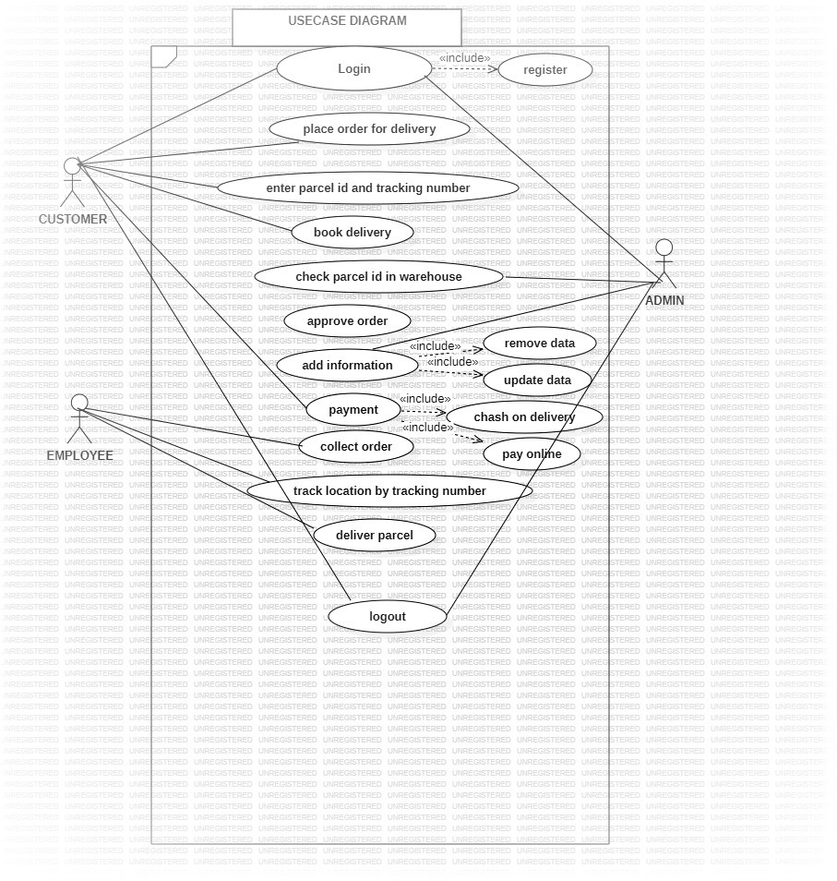
USECASE DIAGRAM
summary:
the diagram above is a use case diagram for courier management system. the user login place order for delivery and then add tracking number admin check the availability of item and confirm the order for booking. The parcel is then assigned to employee ,the employee track location and deliver the item.

ACTIVITY DIAGRAM
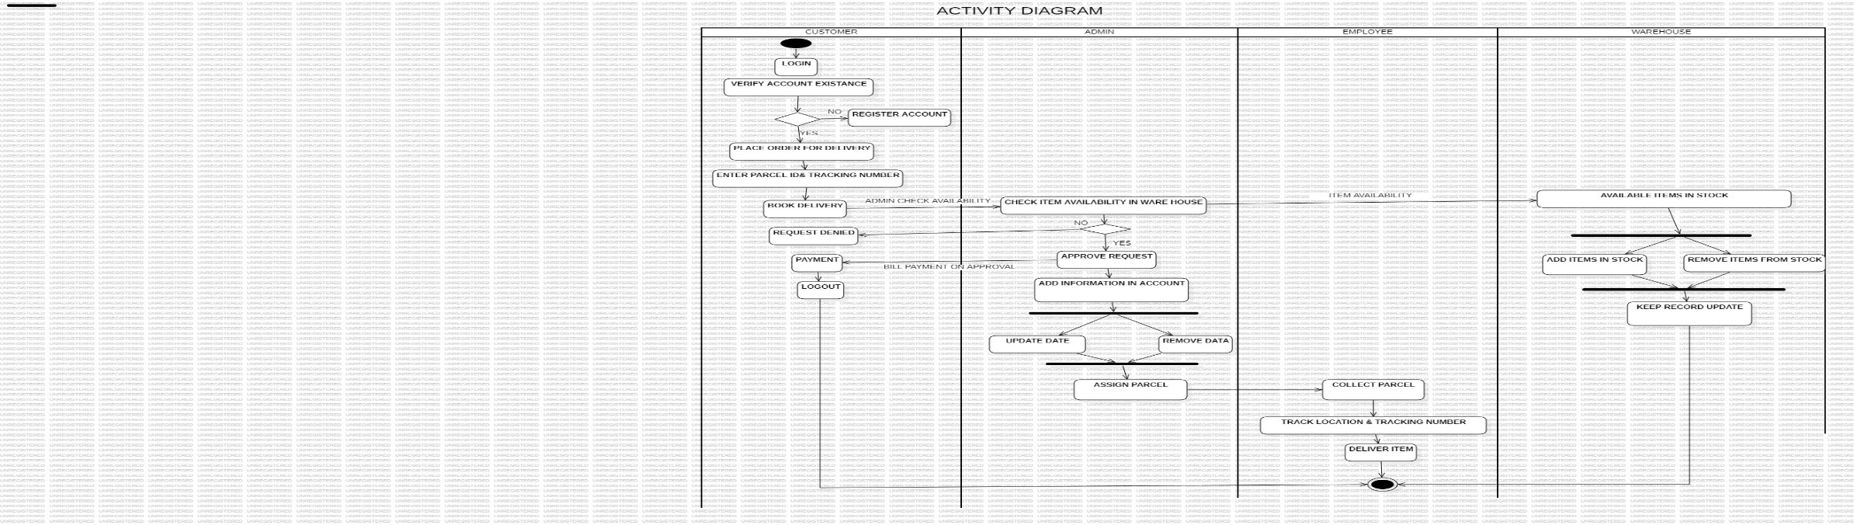
summary:
the activity (swam lane)diagram shows an overall control of a system, the system begins when customer login and place order , after that item availability is checked by the admin in the ware house then the booking is confirmed ,different conditional statements are used for verification and validation of the process. The item is then assigned to employee and delivered to customer, the process ends at final.
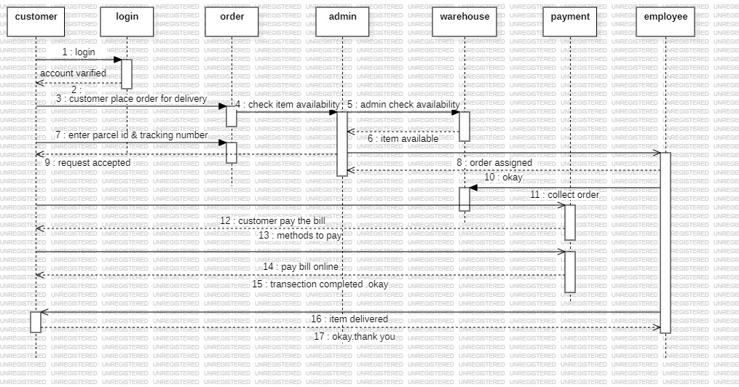
SEQUENCE DIAGRAM

SUMMARY:
A sequence diagram for a Courier Management System effectively captures the interaction between various entities during the process of placing and processing an order. It helps in visualizing the flow of information and the responsibilities of each component, ensuring clarity and aiding in the efficient design and debugging of the system.

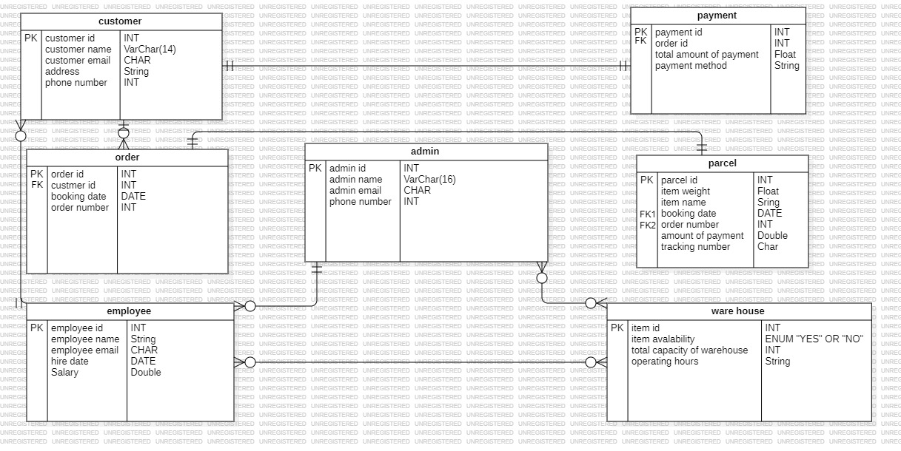
ENTITY RELATIONSHIP DIAGRAM

SUMMARY :
In summary, an ERD is a valuable tool for database design and development, offering a visual representation of the Courier Management System’s structure and relationships. It promotes clarity, collaboration, and efficiency throughout the system development lifecycle.

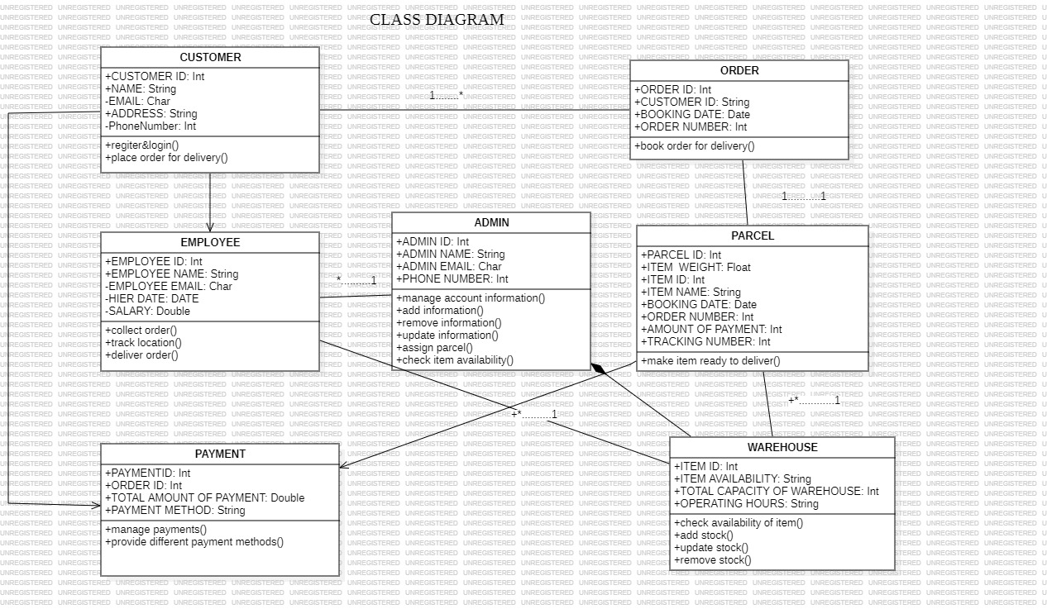
CLASS DIAGRAM

SUMMARY:
In summary, a Class Diagram is a valuable tool for object-oriented design and development, offering a visual representation of the Courier Management System's structure and relationships. It promotes clarity, collaboration, and efficiency throughout the system development lifecycle. It provides different types of relationships, for instant one-to-one ,many-to-many, one-to-many and direct association among the classes

Data flow diagram :
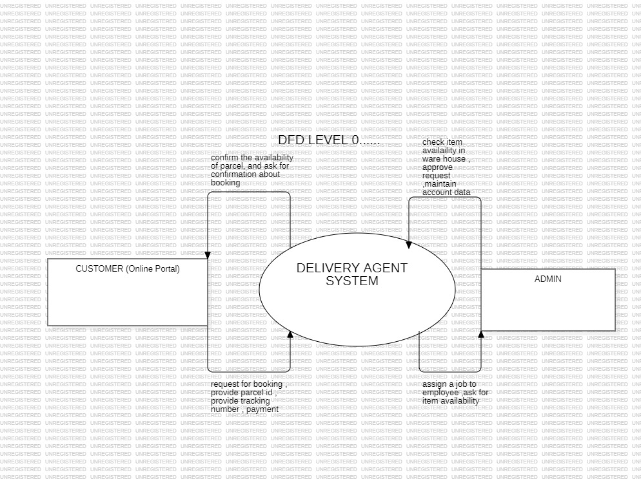
Level 0……context diagram
Summary:
The level 0 DFD diagram shows an overview of system main components and their main functions

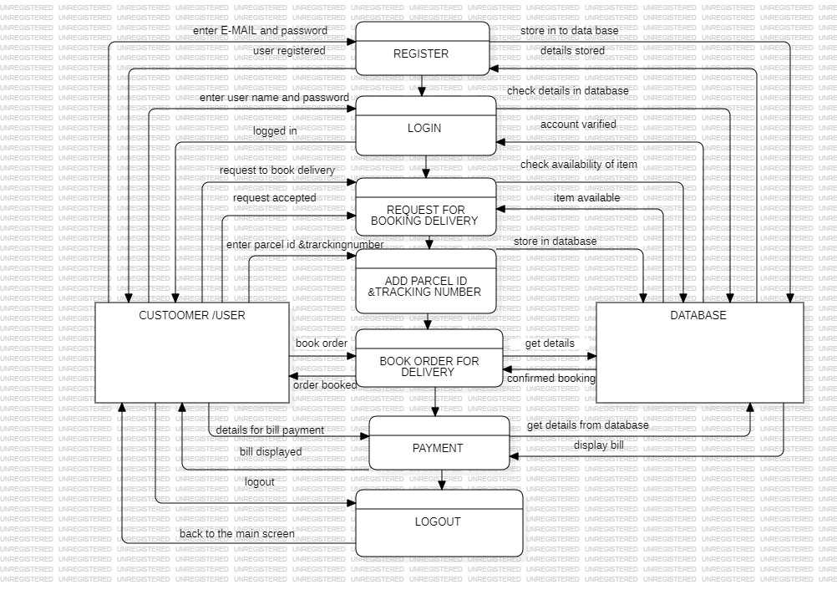
Level 1……..

Summary :
Level one involves the system interaction with external entity user, it shows what and how the user interact with the system and how system responds to the user .

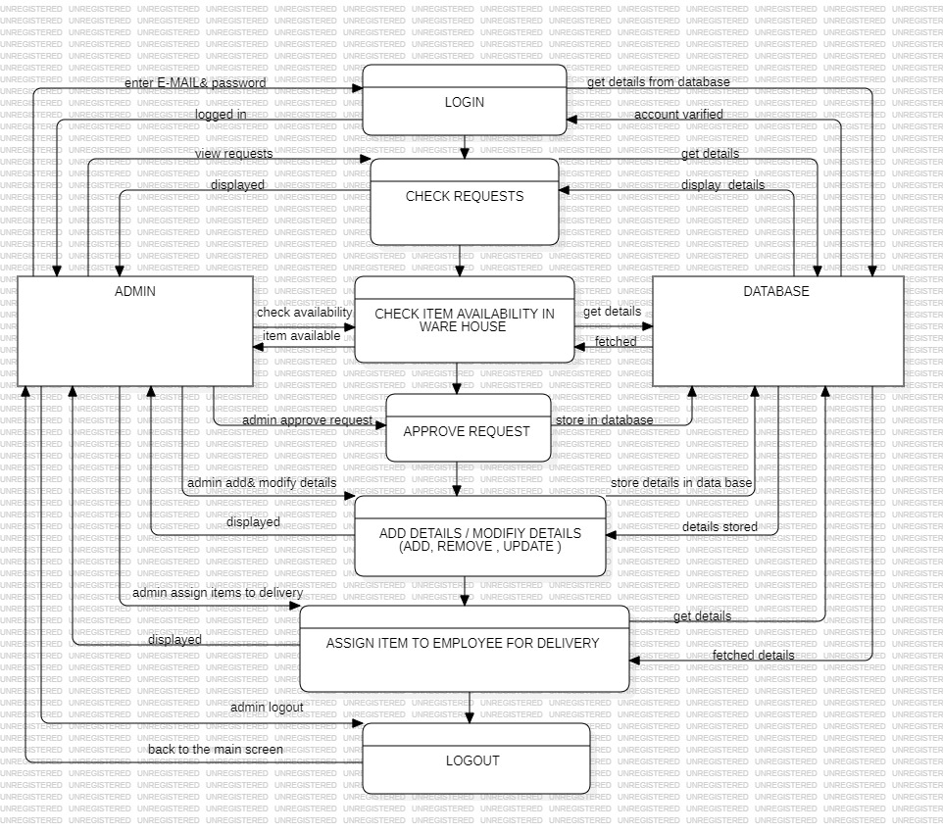
Level 2……

Summary :
The system is further decomposed into parts when admin interact with the system for update remove information and the system database store’s modified data

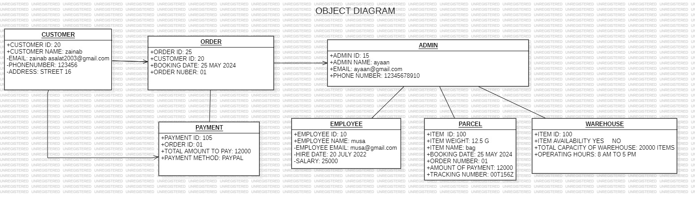
OBJECT DIAGRAM

SUMMARY :
The object diagram mainly give a view of main components\objects of the system and how the system is divided into sub parts, it involves the functions or the objects of the main components of the system

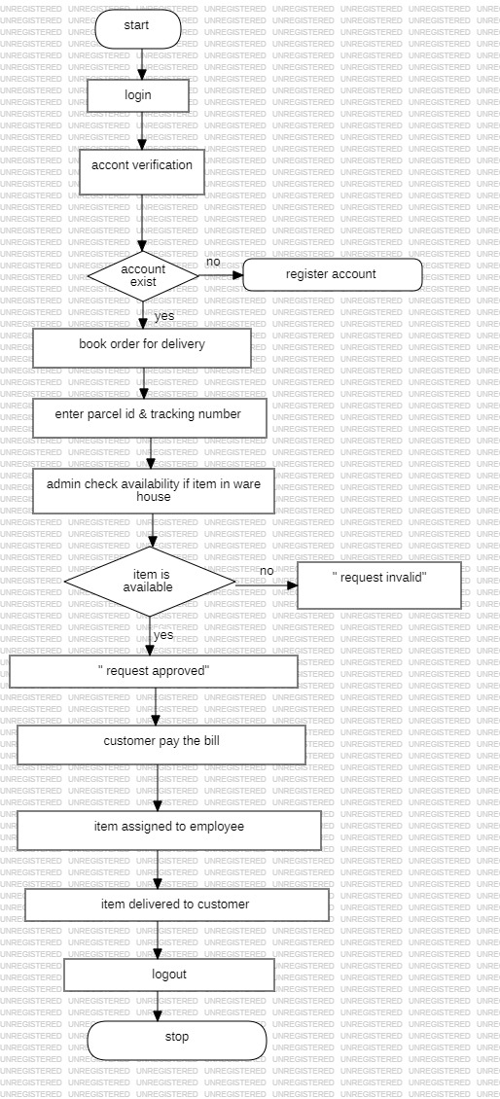
FLOW CHART

SUMMARY:
The flow chart is closely related to the activity diagram as the system begins with login and place order for the registration the if condition is used to check account verification and the item availability is checked by the admin the if condition validate and check availability then item is assigned to the employee and customer pay the bill. The item is then delivered to the customer

